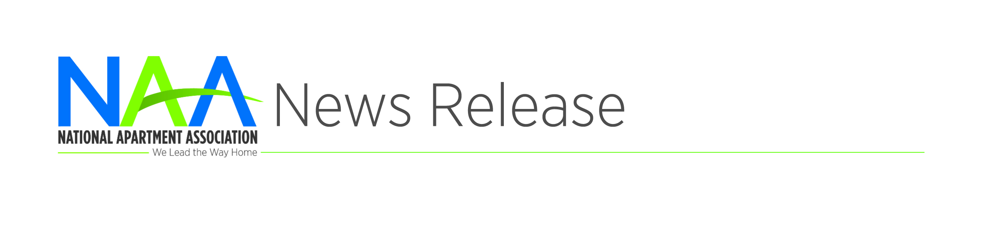
Contact: [Name]
[Phone] or [Email]
[Affiliate] Celebrates Apartment Onsite Teams Day
[CITY, STATE] | August 12, 2020 – Join [Affiliate] as it celebrates Apartment Onsite Teams Day and we show our appreciation for the rental housing industry’s onsite staff who have kept apartment communities operating during the COVID-19 pandemic.
“We can all agree that our industry’s onsite workers have gone above and beyond in serving the over 40 million Americans who call apartments home,” said [Name & Title]. “Our industry does not stop in a crisis. Many have risked their own health and that of their families to take care of their residents in the COVID-19 pandemic while providing safe homes, keeping them maintained properly, working with residents who have financial issues due to COVID-19-induced layoffs or pay reductions, keeping spirits up among residents who must socially distance while working from home and in many cases, educating children from home – these are just a few of the day-to-day responsibilities of rental housing professionals.”
New challenges and new protocols have become the norm and while the crisis is not yet over, our onsite teams deserve recognition for their efforts and amazing work.
Apartment Onsite Teams Day recognizes the men and women who have helped guide apartment communities throughout the country through this unprecedented and uniquely challenging event. Visit [Affiliate web site] for more information about the apartment housing industry and Apartment Onsite Teams Day.
###
About NAA
The National Apartment Association (NAA) serves as the leading voice and preeminent resource through advocacy, education and collaboration on behalf of the rental housing industry. As a federation of 152 affiliates, NAA encompasses over 82,000 members representing more than 10 million apartment homes globally. NAA believes that rental housing is a valuable partner in every community that emphasizes integrity, accountability, collaboration, community responsibility, inclusivity and innovation. To learn more, visit www.naahq.org.
Affiliate Boilerplate

