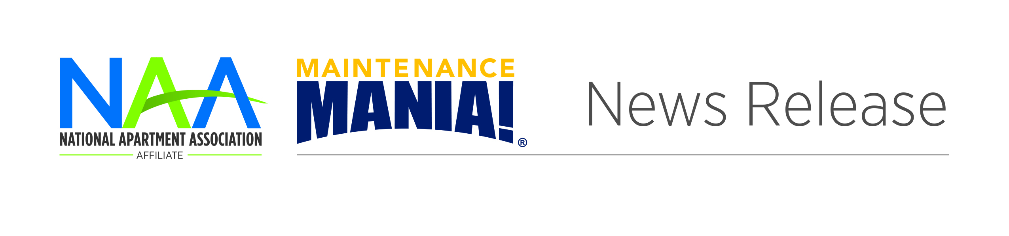

**[Name] Wins Maintenance Mania® Competition**

Contact: First, Last

703-518-6141 or

email@naahq.org

CITY, STATE ABBREVIATION. **|** DATE – The XX [affiliate apartment association] is pleased to announce that XX of XX [name, company] won the XX Maintenance Mania® competition. XX [name] earned first place with an overall time of XX.

The competition—presented by NAA and presenting sponsor HD Supply, a leading distributor of maintenance and renovation products—consists of seven maintenance-focused challenges. This season’s competitors will test their maintenance skills and knowledge of the industry as they compete locally to earn a spot at the 2020 Maintenance Mania® National Championship in June in Boston.

Racing against the clock, these highly skilled maintenance professionals will compete against each other to see who is the fastest at water heater installation, key control, air conditioner repair, icemaker installation, fire & carbon monoxide safety installation, shock treatment setup, and heating installation. The finale of the event concludes with a race car competition, where the competitors build a model car using at least one maintenance product or part and race it down a pinewood derby-style track.

“Maintenance professionals are the unsung heroes of our industry,” said NAA President & CEO Robert Pinnegar, CAE. “These are the people who keep apartment buildings running. Maintenance Mania® gives our industry an opportunity to recognize the professionals who play such an important role in our industry.”

The 2019-2020 Maintenance Mania® season kicked off in September and will continue through April 2020, with an estimated 65 local events scheduled across the country.

For more information on the XXX apartment association event, contact XXXX at (phone number) or (email). Visit XXX apartment association online at (URL).

**ABOUT MAINTENANCE MANIA**Maintenance Mania® is a national competition where apartment maintenance technicians are able to compete against each other in various skill-based games focused on frequent maintenance issues. Maintenance Mania® is offered by the National Apartment Association, a leading advocate for quality rental housing, and presenting sponsor HD Supply Facilities Maintenance, a leading supplier of maintenance, repair and operations (MRO) products to the multifamily industry. Nearly 65 qualifying events are hosted nationwide by regional NAA affiliates, providing 20 top technicians the opportunity to compete at the National Championship to be held in June in Denver. Other 2019-2020 national sponsors include AO Smith®, Frigidaire®, Kidde®, Kwikset®, SmartBurner®, SmartComfort®, and Queenaire Technologies, Inc.

###

###