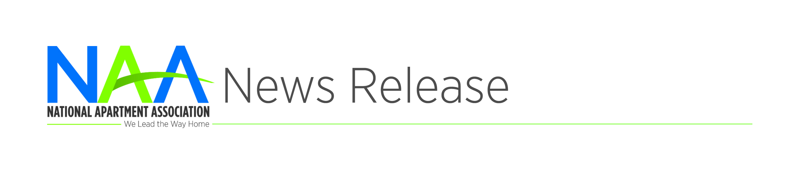
Contact: [Name]
[Phone] or [Email]
[Affiliate] Celebrates National
Apartment Housing Month
[CITY, STATE] | April X, 2019 – Join [Affiliate] as it celebrates National Apartment Housing Month. This year, we’re celebrating the exciting career opportunities available in the greatest industry—apartment housing!
National Apartment Housing Month also offers the opportunity to highlight the philanthropic efforts the rental housing industry makes to [city] through charitable outreach. Additionally, April marks the celebration of Residential Property Management (RPM) Careers Month.
“With one-third of Americans now renting their homes, there has never been a more exciting time to be a part of the apartment housing industry,” said [Name & Title]. “An RPM career provides a great start for college students, grads, military members in transition and well-qualified candidates seeking a career change. Our industry also provides ample opportunities to give back to the community you live in as well. National Apartment Housing Month celebrates the best our industry has to offer.”
National Apartment Housing Day recognizes the continued growth and success of the apartment industry, a diverse line of work with ample opportunity to grow personally and professionally. Visit [Affiliate web site] for more information about the local apartment housing industry, rpm.naahq,org for more information on RPM careers and be sure to use the hashtag #APTmonth when sharing your stories.
###
About NAA
The National Apartment Association (NAA) serves as the leading voice and preeminent resource through advocacy, education and collaboration on behalf of the rental housing industry. As a federation of more than 150 affiliates, NAA encompasses over 81,000 members representing more than 9.6 million apartment homes globally. NAA believes that rental housing is a valuable partner in every community that emphasizes integrity, accountability, collaboration, community responsibility, inclusivity and innovation. NAA thanks its strategic partners Maintenance Supply Headquarters and Yardi. To learn more, visit www.naahq.org.

