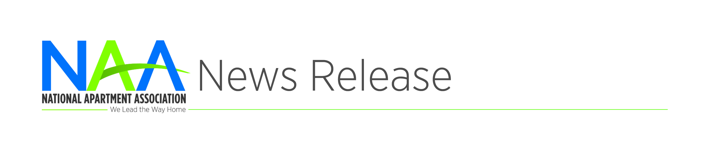

**Contact: Todd Usher**

703-797-0678 or

tusher@naahq.org

**NAA Celebrates Apartment Housing Day on April 6**

**ARLINGTON, VA | April X, 2017** – On Thursday, April 6, National Apartment Housing Day returns as NAA’s members, affiliates and supplier partners across the country celebrate working in the greatest industry—apartment housing!

Now is the time for NAA affiliates and supplier partners to start planning to spread the word about the exciting opportunities in our industry. This year, we are encouraging affiliates to get involved in a variety of activities to promote the benefits of careers in residential property management (RPM), including:

* Working with local colleges to host events for prospective industry hires
* Speaking or participating in panels of RPM professionals at events
* Sponsoring career fairs
* Holding property tours with interested students

“With one-third of Americans now renting their homes, there has never been a more exciting time to be a part of the apartment housing industry,” said Robert Pinnegar, CAE, President & CEO of the National Apartment Association. “An RPM career provides a great start for college students, grads, military members in transition and well-qualified candidates seeking a career change.”

National Apartment Housing Day recognizes the continued growth and success of the apartment industry. Visit [www.naahq.org](http://www.naahq.org) for updates, and be sure to use the hashtag #aptday to share your industry stories and post to NAA’s social media platforms.

###

###