**Thursday, September 19 ● 11:00 a.m. – 4:00 p.m.**

**Are you the fastest Maintenance Tech around? Prove it!**  
Participate in our upcoming Maintenance Mania® event and show us your skills by completing 7 maintenance-focused challenges. Fastest time wins!

The winner of our event will get the chance to qualify for a spot at the National Championship held at Apartmentalize on June 17, 2020 in Boston and be crowned the title of Maintenance Mania® National Champion.

If you are up for the challenge and would like to participate in our upcoming Maintenance Mania® event, be sure to build a race car from maintenance products ahead of the event to race it down a 32’ long track. You will receive your official race car wheels as soon as you sign up.

**Event Details  
Date/Time:** Thursday, September 19, 11:00 a.m. – 4:00 p.m.  
**Location:** City Convention Center**,** 101 Main Street**,** Springfield, XZ 19000

**Contact:** John Doe at (555) 555-5555

Win or lose, you are destined to have a great time. Grab your spot by registering today.

*\*Participants must compete in all seven challenges plus enter the car in the race car competition to be able to qualify for a spot in the National Championship.*

**INSERT AA LOGO**

***National Sponsors:***

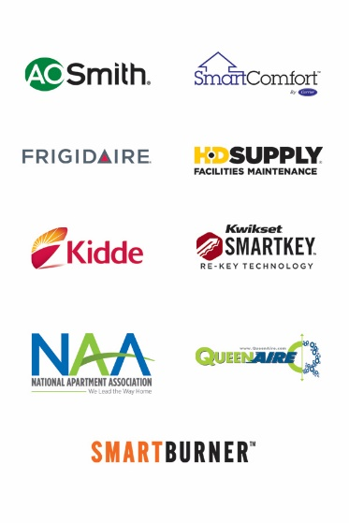

**Thursday, September 19 ● 11:00 a.m. – 4:00 p.m.**

**Are you the fastest Maintenance Tech around? Prove it!**  
Participate in our upcoming Maintenance Mania® event and show us your skills by completing 7 maintenance-focused challenges. Fastest time wins!

The winner of our event will get the chance to qualify for a spot at the National Championship held at Apartmentalize on June 17, 2020 in Boston and be crowned the title of Maintenance Mania® National Champion.

If you are up for the challenge and would like to participate in our upcoming Maintenance Mania® event, be sure to build a race car from maintenance products ahead of the event to race it down a 32’ long track. You will receive your official race car wheels as soon as you sign up.

**Event Details  
Date/Time:** Thursday, September 19, 11:00 a.m. – 4:00 p.m.  
**Location:** City Convention Center**,** 101 Main Street**,** Springfield, XZ 19000

**Contact:** John Doe at (555) 555-5555

Win or lose, you are destined to have a great time. Grab your spot by registering today.

*\*Participants must compete in all seven challenges plus enter the car in the race car competition to be able to qualify for a spot in the National Championship.*

**INSERT AA LOGO**

***National Sponsors:***

Thank You To Our Sponsors

Thank You To Our Sponsors