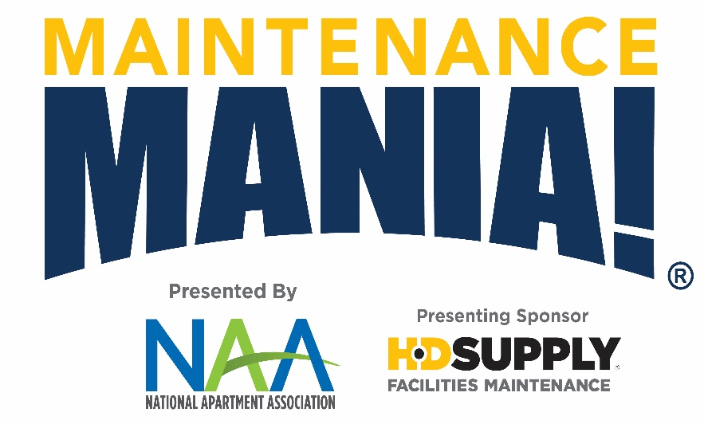  Are you the fastest Maintenance Tech around? Prove it!  Come and compete in maintenance-focused challenges, you could earn the title of Maintenance Mania® National Champion.  Build a race car from maintenance products ahead of the event to race it down a 32’ long track. Win or lose, you are destined to have a great time. Grab your spot by registering today.  *You must compete in all seven challenges plus enter a car in the race car competition to be able to qualify for a spot in the National Championship. | What is Maintenance Mania?  Maintenance Mania® is a national program offered by NAA and presenting sponsor HD Supply (HDS), in which maintenance technicians compete against each other in various skill-based games. Participate in our upcoming Maintenance Mania® event and show us your skills by completing 7 maintenance-focused challenges. Fastest time wins! Learn more details here: https://www.naahq.org/maintenance-mania  8 Challenges Await You:  - AO Smith Water Heater Installation  - Queenaire Shock Treatment Setup  - Frigidaire Icemaker Installation  - Kidde Fire & Carbon Monoxide Safety Installation  - Kwikset Key Control Deadbolt Test  - SmartBurner™ Heating Element Installation  - Smart Comfort Air Conditioner Repair  - Race Car Competition  Event Schedule  - Car check-in opens: 11:00 a.m.  - Practice time: 11:00 a.m. – 12:00 p.m. Check out all the games!  - Competition begins: 12:00 p.m.  When & Where?  Thursday, September 19, 11:00 a.m. – 4:00 p.m.  City Convention Center  101 Main Street  Springfield, XZ 00000
INSERT AA LOGO
TBD Apartment Association
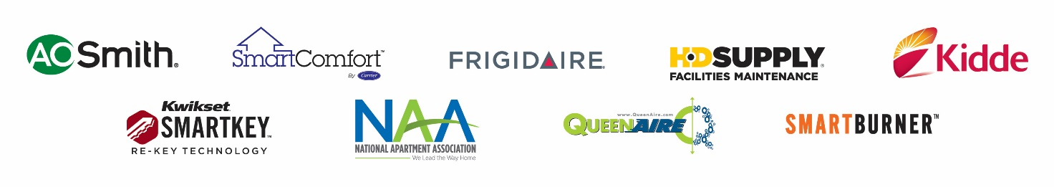
Locally Sponsored By:
Station/Judge Sponsors

Other Sponsors

Food Sponsors

Prize Sponsors

National Sponsors:

