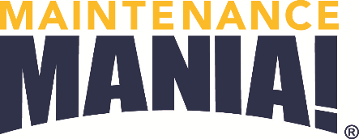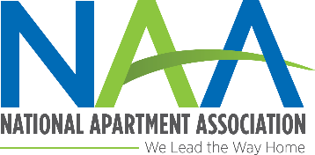

American Apartment Association

**What is Maintenance Mania?**

A competition in which apartment pros like you from around the country face maintenance-focused challenges that test their skills and knowledge to earn the title of Maintenance Mania® National Champion*. Check out video on www.aptassociation.org.

**8 challenges await you:**

* AO Smith Water Heater Installation
* Fluidmaster Duo Flush Toilet Conversion
* Frigidaire Icemaker Installation
* Kidde Fire & Carbon Monoxide Safety Installation
* Kwikset Key Control Deadbolt Test
* SmartBurner™ Heating Element Installation
* Smart Comfort Air Conditioner Repair
* Race Car Competition

**Are you the fastest?**

**Here’s your chance to prove it!**

All you have to do is build a racecar from maintenance products ahead of the event to race it down a 32’ long track. And if you just want to have a good time, then come and try your hand at one or all of the games.

**Event Schedule**

* Car check-in opens: 11:00 a.m.
* Practice time: 11:00 a.m. – 12:00 p.m. Check out all the games!
* Competition begins: 12:00 p.m.

**Where?**

City Convention Center

101 Main Street

Springfield, XZ 00000

*Food Sponsors*

*Station/Judge Sponsors*

*Prize Sponsors*

*Other Sponsors*

*You must compete in all seven challenges plus enter a car in the race car competition to be able to qualify for a spot in the National Championship.

**Thursday, March 24, 2017**

**11:00 AM – 4:00 PM**

AA Logo

***Presenting Sponsor:***

***Locally sponsored by:***

***National Sponsors:***