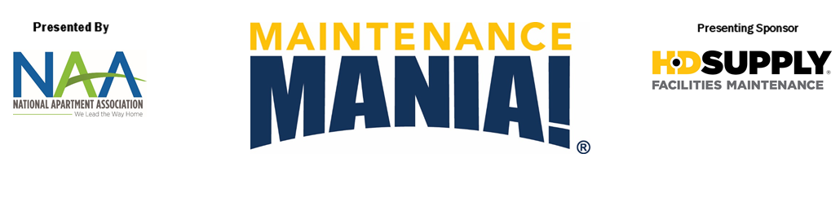

*You must compete in all seven challenges plus enter a car in the race car competition to be able to qualify for a spot in the National Championship.

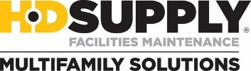

**Sign up today to receive**

**your official race car wheels**

**and get started on your car!**

Thursday, March 24, 2016

11:00 AM – 4:00 PM

**Are you the fastest? Here’s your chance to prove it!**

Come and compete in maintenance-focused challenges, you could earn the title of Maintenance Mania® National Champion.

Build a race car from maintenance products ahead of the event to race it down a 32’ long track. You are sure to have a darn good time at one or all of the games*.

**Where?**

City Convention Center

101 Main Street

Springfield, XZ 19000

**Contact:** John Doe at (555) 555-5555

**Check out the video on www.aptassociation.org**

**Are you the fastest? Here’s your chance to prove it!**

Come and compete in maintenance-focused challenges, you could earn the title of Maintenance Mania® National Champion.

Build a race car from maintenance products ahead of the event to race it down a 32’ long track. You are sure to have a darn good time at one or all of the games*.

**Where?**

City Convention Center

101 Main Street

Springfield, XZ 19000

**Contact:** John Doe at (555) 555-5555

**Check out the video on www.aptassociation.org**

Thursday, March 24, 2016

11:00 AM – 4:00 PM

*You must compete in all seven challenges plus enter a car in the race car competition to be able to qualify for a spot in the National Championship.

AA Logo

***Sponsored by:***



AA Logo

***Sponsored by:***

**Sign up today to receive**

**your official race car wheels**

**and get started on your car!**