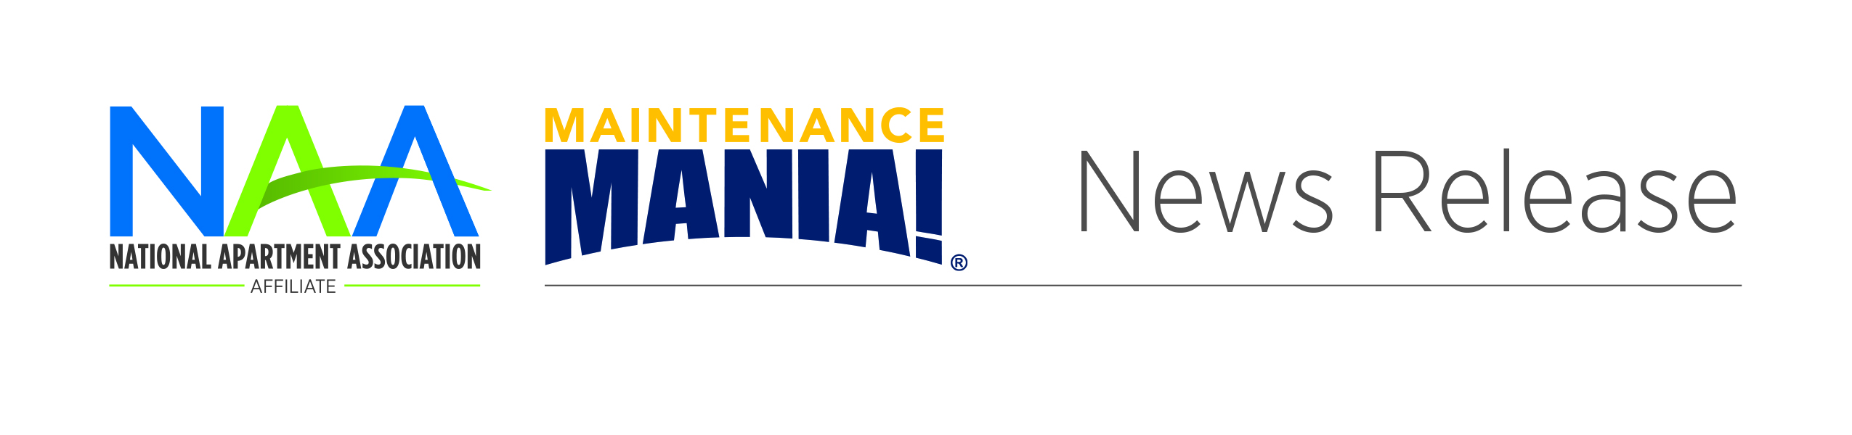

Contact: First, Last

703-518-6141 or

email@naahq.org

**[Name] Wins Maintenance Mania® Competition**

CITY, STATE ABBREVIATION. / DATE – The XX [affiliate apartment association] is pleased to announce that XX of XX [name, company] won the XX Maintenance Mania® competition. XX [name] earned first place with an overall time of XX.

The competition—presented by NAA and presenting sponsor HD Supply, a leading distributor of maintenance and renovation products—consists of eight maintenance-focused challenges. This season’s competitors will test their maintenance skills and knowledge of the industry as they compete locally to earn a spot at the 2017 Maintenance Mania® National Championship in June in San Francisco.

Racing against the clock, these highly skilled maintenance professionals will compete against each other to see who is the fastest at water heater installation, key control, faucet installation, icemaker installation, fire & carbon monoxide safety installation, toilet conversion, and ceiling fan installation. The finale of the event concludes with a race car competition, where the competitors build a model car using at least one maintenance product or part and race it down a pinewood derby-style track.

“Maintenance professionals are the unsung heroes of the multifamily housing industry,” said NAA President and CEO Doug Culkin, CAE. “These dedicated men and women are the backbone of apartment communities, and NAA’s Maintenance Mania® program showcases the best of the best in the industry. We’re extremely proud to be able to shine a light on such an outstanding group of individuals.”

The 2016-2017 Maintenance Mania® season kicked off in September and will continue through April 2017, with an estimated 60 local events scheduled across the country.

For more information on the XXX apartment association event, contact XXXX at (phone number) or (email). Visit XXX apartment association online at (URL).

**ABOUT MAINTENANCE MANIA**

Maintenance Mania is a national competition where apartment maintenance technicians are able to compete against each other in various skill-based games focused on frequent maintenance issues. Maintenance Mania is offered by the National Apartment Association, a leading advocate for quality rental housing, and presenting sponsor HD Supply Facilities Maintenance, a leading supplier of maintenance, repair and operations (MRO) products to the multifamily industry. Nearly 70 qualifying events are hosted nationwide by regional NAA affiliates, providing 20 top technicians the opportunity to compete at the National Championship to be held in June in San Francisco. Other 2015-2016 national sponsors include AO Smith, Cleveland Faucet Group, Fluidmaster®, Frigidaire, Kidde, Kwikset®, and Seasons.

###

###