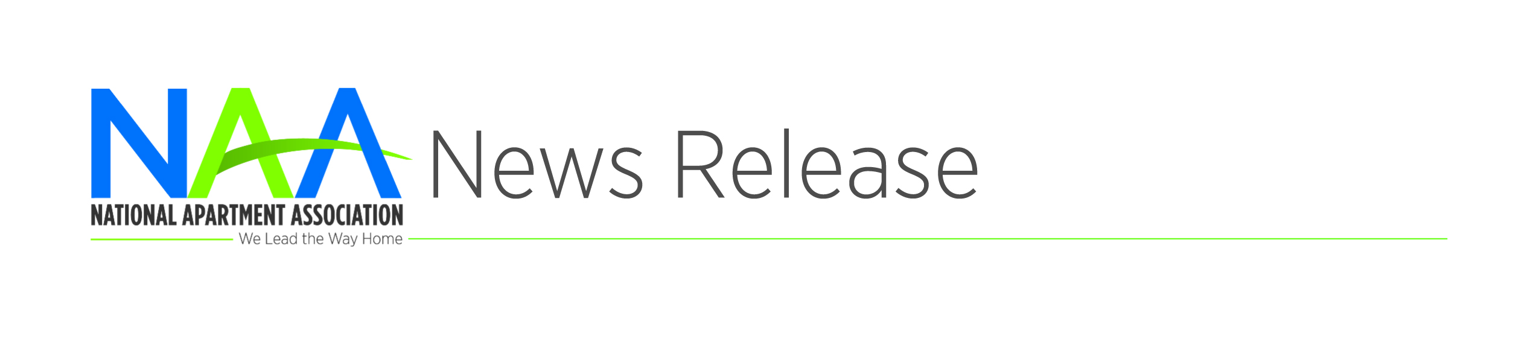

**[Affiliate] Celebrates National**

**Apartment Housing Day**

**Contact: [Name]**

[Phone] or [Email]

**[CITY, STATE] | April X, 2017** – Join [Affiliate] as it celebrates National Apartment Housing Day on [date and time]. This year, we’re celebrating the exciting career opportunities available in the greatest industry—apartment housing!

National Apartment Housing Day coincides with Residential Property (RPM) Careers Month. RPM careers are ideal for college students, recent grads, transitioning military members and people seeking a career change.

“With one-third of Americans now renting their homes, there has never been a more exciting time to be a part of the apartment housing industry,” said [Name and title of leader]. “The apartment industry offers a wealth of meaningful career opportunities that use a variety of skills and capabilities. We encourage well-qualified candidates to check our industry out and see for themselves just how great it is.”

The apartment housing industry is diverse with plenty of opportunities for advancement. Certification is also available through the NAA Education Institute to help you grow and advance your RPM career.

National Apartment Housing Day recognizes the continued growth and success of the apartment industry. Visit [Affiliate web site] for more information about the local apartment housing industry and [rpm.naahq,org](http://rpm.naahq.org/) for more information on RPM careers.

###

###