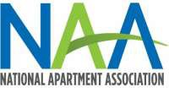
Marc Ross, CAPS
Chairman of the 2017 Hall of Fame Committee has issued this Call for Recommendations
for the Hall of Fame Committee’s Consideration

The NAA Hall of Fame recognizes owner/managers from the multihousing industry for their long-term history of exemplary national service and accomplishments to the National Apartment Association and the apartment industry. The Hall of Fame Committee is soliciting nominations for possible presentation of this award during the NAA Education Conference and Exposition.

YOUR NAME:
- I wish to recommend the following member to the Hall of Fame Committee for consideration to the NAA Hall of Fame.

NAME COMPANY CITY/STATE
Please provide a brief summary outlining the contributions this member has made to the industry and the association that would warrant his/her consideration by the Hall of Fame Committee.
Thank you!

Please return the nomination form to Judy Reynolds by March 24th @ jreynolds@naahq.org

