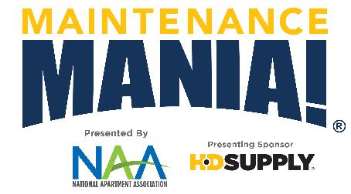

Upcoming Maintenance Competition ● Date

[INSERT AA NAME HERE] is looking for the fastest maintenance techs around. Do they work at your property? Invite your entire maintenance team to come and compete in Maintenance Mania® where they can compete in maintenance-focused challenges and earn the title of Maintenance Mania® National Champion.
INSERT AA LOGO

What is Maintenance Mania®?
National Sponsors:
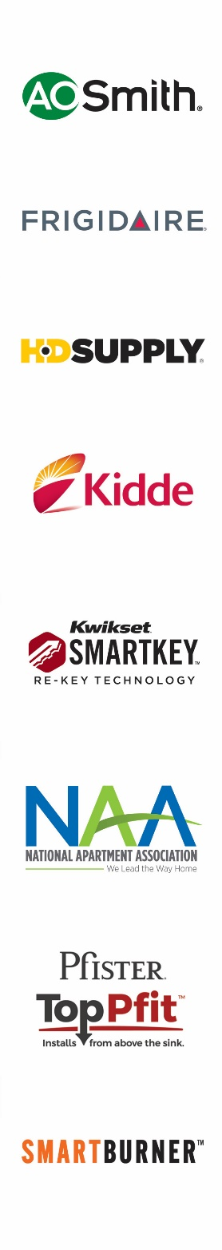
Maintenance Mania® is a national program offered by NAA and presenting sponsor HD Supply (HDS), in which maintenance technicians compete against each other in various skill-based games. Invite your technicians to our upcoming Maintenance Mania® event where they can showcase their skills by completing 7 maintenance-focused challenges. Fastest time wins! Learn more details here: https://www.naahq.org/maintenance-mania

7 Challenges to Prove Their Skill:
- AO Smith Water Heater Installation
- Pfister TopPfit Faucet Installation
- Frigidaire Icemaker Installation
- Kidde Fire & Carbon Monoxide Safety Installation
- Kwikset Key Control Deadbolt Test
- SmartBurner™ Heating Element Installation
- Race Car Competition

All technicians who would like to compete are required to build a race car from maintenance products ahead of the event. They can compete in one or all games. Win or lose, with your cheers and support everyone is destined to have a great time.
Event Schedule

- Car check-in opens: 11:00 a.m.
- Practice time: 11:00 a.m. – 12:00 p.m. Check out all the games!
- Competition begins: 12:00 p.m.
When & Where?
Thursday, September 19, 11:00 a.m. – 4:00 p.m.
City Convention Center

101 Main Street
Springfield, XZ 19000

Contact: John Doe at (555) 555-5555

*Participants must compete in all seven challenges plus enter a car in the race car competition to be able to qualify for a spot in the National Championship.

