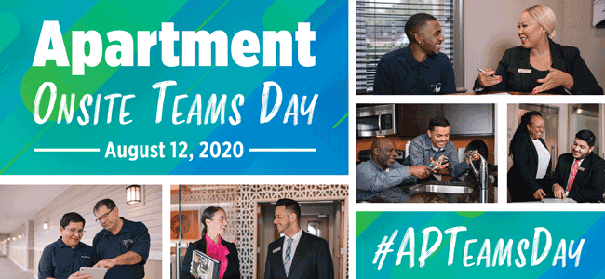

Social Media Post Samples

Post 1: You have done amazing work during this crisis and we are devoting a day just to you, introducing Apartment Onsite Teams Day! Join us Wednesday, August 12, for a day of thanks with free meals, gift cards, t-shirts and more for all apartment onsite team members. Use the official hashtag, #APTeamsDay when you share photos and videos on social media of the special day. We want to thank you the best way we know how!
Post 2: Have you heard? We are celebrating you for all of the vital work you are doing in your rental housing community with a day devoted to you. Join us Wednesday, August 12 for our Apartment Onsite Teams Day where we will provide you with free meals, gift cards, t-shirts and more for all onsite team members. You’ve been here for us and we want you to know that we are here for you, too!
Post 3: For months, you’ve been onsite, doing the vital work to keep residents safe during this crisis. Due to this commitment, we are celebrating you Wednesday, August 12 with Apartment Onsite Teams Day, a day filled with fun, free food, gift cards, t-shirts and more for all onsite apartment team members. Don’t forget to use our official hashtag, #APTeamsDay when you post photos and videos on social media from the special day. Let us thank you by celebrating you the best way we know how.
Post 4: The apartment onsite teams have been on the forefront of the COVID-19 crisis, helping residents stay safe as they stay home. For this, we want to thank and celebrate you on Wednesday, August 12 with Apartment Onsite Teams Day. You’ll get food, gift cards, t-shirts and more for all onsite apartment team members. And when you take photos and videos of your celebration, use our official hashtag, #APTeamsDay on all social media. We want to thank you, the best way we know how.
Post 5: Today is Apartment Onsite Teams Day, a day where the rental housing industry thanks our vital workers who have been at the forefront of COVID-19 crisis, helping residents stay safe as they stay home. You’ll receive food, fun and giveaways, and while you’re celebrating and taking photos and videos, use our official hashtag, #APTeamsDay on social media. Thank you for your dedication! Enjoy!

