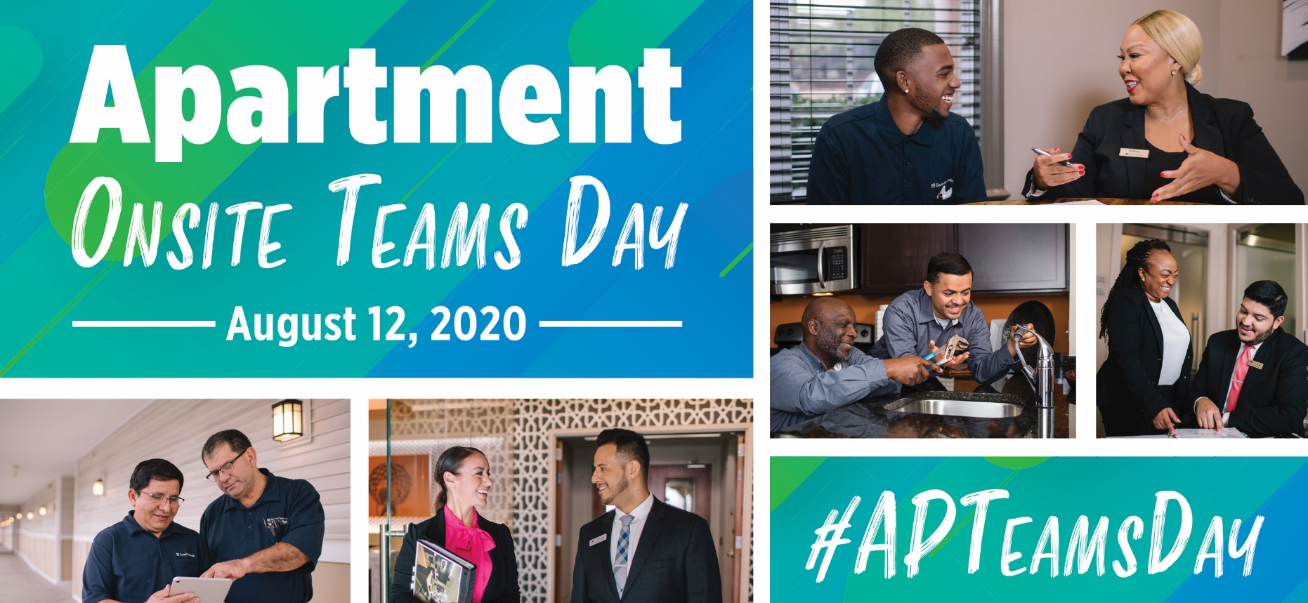

Inspirations to Celebrate
Apartment Onsite Teams Day
August 12, 2020 is Apartment Onsite Teams Day, so join in the fun to raise awareness and show our appreciation for the rental housing industry’s onsite staff!
This inspiration list and the toolkit are provided as tools that can help you, your employees and your industry partners spread the word about #APTeamsDay.

Social media shout out
Use sample social posts and graphics provided in the toolkit to share across your social media channels. Encourage your team to post photos with the hashtag #APTeamsDay.

Promote #APTeamsDay on your website

Add digital ads provided in the toolkit on your website. This is also an opportunity to feature your onsite team pictures on the website.

Giveaways
- Appreciation gift boxes filled with special treats make staff feel special on the event day. Even a small gift to show employee recognition, like a $10 gift card, can make someone's day.
- Greeting cards with thank you messages show your staff that you value them and their hard work. Better yet, create a giant greeting card for residents to sign.
- T-shirts personalized with #APTeamsDay and your company logo are a perfect giveaway for staff and for property publicity anytime, anywhere.

Free food
- Have a pizza party! Offering onsite lunches is a great way to encourage staff to stick around during their lunch breaks, giving them the opportunity to celebrate their day with co-workers.
- Surprise the team with an Ice Cream Truck treat to show how much their hard work means to you. Much needed on a hot summer day.
- Organize a potluck lunch! Encourage people to bring a dish that represents their culture or bring their favorite food.

TikTok videos
Ask your employees to record fun TikTok videos and share them on social. Don’t forget to use our official hashtag #APTeamsDay.

Yard signs/Flyers
Install yard signs or post flyers around your property to raise awareness about #APTeamsDay. Let your residents acknowledge all the amazing work of your onsite teams and celebrate with us.

Collect employee ideas
You can always collect different appreciation ideas and take a vote on what they prefer to do on the event day.

