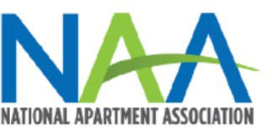

August 11, 2022

The Honorable Joseph R. Biden, Jr.
President
The White House
1600 Pennsylvania Ave, NW
Washington, D.C. 20500

Dear President Biden:

The National Multifamily Housing Council (NMHC) and the National Apartment Association (NAA) are reaching out today to share with you our thoughts relative to the issues discussed during the White House’s Emergency Rental Assistance to Ensure Long-Term Eviction Reform summit. We applaud the Biden Administration for its whole-of-government approach to addressing the root causes of housing instability and working to leverage federal resources to protect the financial security of both renters and rental property owners. We look forward to collaborating with you to promote sustainable and responsible solutions to the issues facing housing providers and their residents. Further, we urge lawmakers to reject price control/rent control measures, as they only lead to a disinvestment in housing.

The thousands of housing providers who serve the nation’s 40 million renters are critical members of every community. In addition to supplying housing, they support 17.5 million jobs1 and contribute $3.4 trillion to U.S. economy annually.2 As was seen during the pandemic, they also step up in times of crisis and work with their residents to keep them stably and safely housed. The fate of the nation’s renters is inexorably tied to housing providers and only through a fair and equitable partnership can our housing ecosystem function effectively. That is why the housing provider perspective is crucial to this important topic.

For more than 25 years, NAA and NMHC have partnered to provide a single voice for America’s rental housing industry. Our combined memberships are engaged in all aspects of the rental housing, including ownership, development, management, and finance. NMHC represents the principal officers of the apartment industry’s largest and most prominent firms. NAA is a federation of 145 state and local affiliated apartment associations, which encompasses 93,000 small, medium, and large housing providers representing nearly 11.5 million apartment homes globally.

Protecting Residents Means Addressing Housing Affordability Challenges
Due to a lack of supply, millions of American families are struggling to meet their housing costs in communities nationwide. That is, if they can even find a place to call home. Simply put, families at all income levels struggle to find housing they can afford because, in too many communities, it cannot be built.

1 NMHC tabulations of 2020 American Community Survey microdata.
2 Hoyt Advisory Services, National Apartment Association and National Multifamily Housing Council, “The Contribution of Multifamily
NAA and NMHC made the case for more supply of rental housing even before the pandemic. The efforts to date by Congress and the Administration to improve housing affordability are important, but more action is needed. We also recognize that renters need help in the short-term to bridge between today’s challenging economic environment and a future when there are quality rental homes available at all price points for Americans who need them.

We would, however, urge the Administration to proceed cautiously as you consider adding more federal involvement to the landlord-tenant relationship that is already highly regulated by state and local law. Many of these proposals are made with good intentions, however, they have a net negative effect on the very people they are intended to serve and will set back critical efforts to address the nation’s housing affordability challenges. Some dramatically so.

Affordable Housing Challenges Persist, As Demand Remains Strong
It is essential that we build housing at all price points to meet the wide range of demand needs. Federal policy must recognize that the availability of affordable housing is a significant barrier to housing stability.

According to a new study conducted by Hoyt Advisory Services and Eigen10 Advisors, LLC, and commissioned by NMHC and NAA, the U.S. is facing a pressing need to build 4.3 million new apartment homes by 2035.3 Key findings include:

- Shortage of 600,000 Apartment Homes. The 4.3 million apartment homes needed includes an existing 600,000 apartment home deficit because of underbuilding due in large part to the 2008 financial crisis.
- Loss of Affordable Units. The number of affordable units (those with rents less than $1,000 per month) declined by 4.7 million from 2015 to 2020.
- Homeownership. Apartment demand also factors in a projected 3.8% increase in the homeownership rate.
- Immigration. Immigration is a significant driver of apartment demand, and levels tapered before the pandemic and have remained low. A reversal of this trend would significantly increase apartment demand.
- Texas, Florida, and California. These three states account for 40% of future demand and will require 1.5 million new apartments by 2035.

The data include an estimate of the future demand for apartments in the United States, the 50 states and 50 metro areas, including the District of Columbia. For more information on this research, please visit the We Are Apartments website.

3 Hoyt Advisory Services, “Estimating the Total U.S. Demand for Rental Housing by 2035.” (2022), https://www.weareapartments.org/.

Barriers to Development Are Getting in the Way of Meeting Demand
Rental housing providers stand ready to help meet current and future demand but cannot do it alone. Federal, state, and local policymakers also must play a role.

Caution Against Price Controls/Rent Control: NAA and NMHC urge lawmakers to reject price controls and address renters’ housing insecurity by improving and fully funding established, means tested housing subsidy programs like Section 8. We support expanding the availability of vouchers and supplementing administrative fees for public housing authorities that manage these programs.

It is difficult to find any issue where economists on both sides of the political spectrum agree, except for rent control. Forbes lists the antiquated idea as one of the 10 worst economic ideas of the 20th century, saying: “Here we have a policy initiative that has done huge damage to cities around the globe. It is very hard today to find an economist supporting rent control.” It’s little surprise that finding supporters for rent control is difficult. A survey by the American Economic Association found that 93 percent of U.S. economists agreed that rent control reduces the quality and quantity of available housing.

Decades of research and real-world case studies show that rent regulation devastates rental housing and harms affordability. Rent regulation will not add a single new unit of housing. In fact, it has the opposite effect. Since voters approved rent stabilization measures in St. Paul last November, apartment construction has slowed by a whopping 80 percent.

Rent controls distort the housing market by deterring or discouraging the development of rental housing and investment in maintenance and rehabilitation. With little to no ability to earn a profit, investors will shift their investments to other non-rent regulated jurisdictions. In practice, these policies have the effect of increasing the cost of all housing by forcing a growing community to compete for fewer housing units and reducing the quality of rental housing.

NAA and NMHC encourage lawmakers to promote proven alternatives to rent control that address the critical affordable housing shortage, making rents more affordable to lower-income residents and encouraging development of new housing at a variety of rental levels. Voucher-based rental assistance programs, for example, are a more effective way to promote affordable housing in a manner that benefits both the renter and the housing provider.

Regulatory Obstacles: Regulatory, administrative, and political obstacles on all levels of government prevent us from delivering the housing our country so desperately needs. In a recent survey, NAA asked public and private housing professionals to rank the various factors that complicate the development process, thereby impacting housing availability and affordability.

The results below indicate that in addition to the importance of land availability, input from local citizens significantly influences development. Further, rising land and labor costs are inhibiting the production of affordable housing. And, finally, complex approval systems impact affordability issues.4
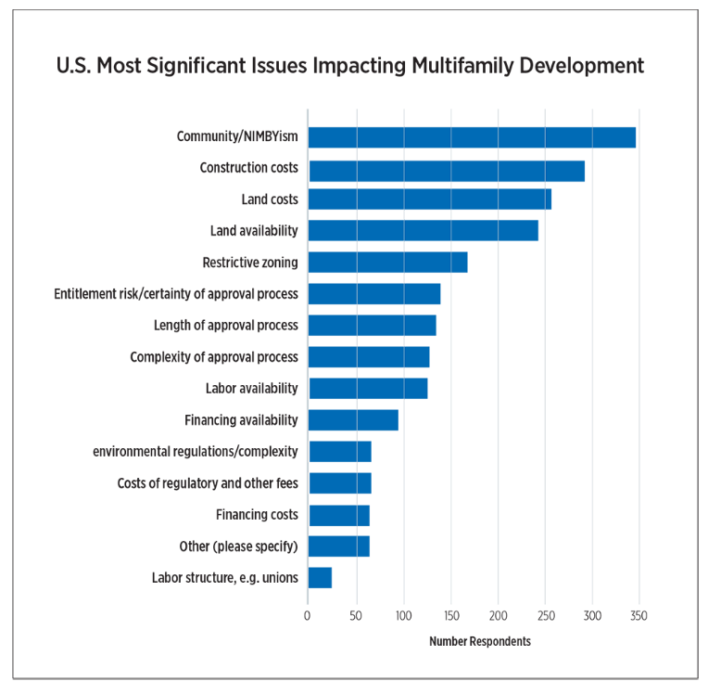

Even in communities that want and desperately need rental housing development, we face hurdles like zoning restrictions, rent control and other onerous local requirements (like building code provisions that have nothing to do with health or safety, land or infrastructure donation requirements and ill-fitting transportation and parking mandates). All of which account for 40.6 percent of multifamily costs further impacting affordability – according to new research released by NMHC and the National Association of Home Builders.5

⁴ U.S. Barriers to Apartment Construction Index, National Apartment Association, 2019, updated 2022.
5 National Multifamily Housing Councill and National Association of Home Builders Regulation: 40.6 Percent of the Cost of Multifamily Development, https://www.nmhc.org/globalassets/research--insight/research-reports/cost-of- regulations/2022-nahb-nmhc-cost-of-regulations-report.pdf

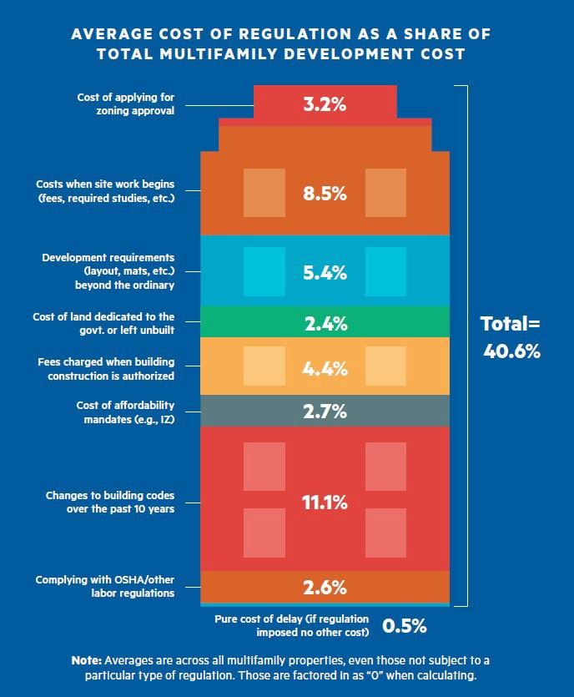

This research illustrates how unnecessary and duplicative regulation can negatively impact developing housing that is affordable. Although smart regulations can play an important role in ensuring the health and well-being of the American public, the NMHC- NAHB research found that many regulations can go far beyond those important goals and impose costly mandates on developers that drive housing costs higher.

Easing regulations could go a long way to address the housing affordability challenges faced by communities across the nation while making critical investments in infrastructure of all types. To that end, we urge lawmakers to craft legislation that will incentivize states and localities to:

- Reduce barriers;
- Streamline and fast track the entitlement and approval process;
- Provide density bonuses and other incentives for developers to include workforce units in their properties;
- Enable “by-right” zoning and create more fully entitled parcels;
- Defer taxes and other fees for a set period of time;
- Lower construction costs by contributing underutilized buildings and raw land; and

- Create incentives to encourage higher density development near jobs and transportation

In addition, the federal Yes In My Backyard (YIMBY) Act (S. 1614 and H.R. 3198) would help to eliminate discriminatory land use policies and remove barriers that depress production of housing in the United States. By requiring Community Development Block Grant (CDBG) recipients to report periodically on the extent to which they are removing discriminatory land use policies, and promoting inclusive and affordable housing, it will increase transparency and encourage more thoughtful and inclusive development practices. Housing affordability is a national problem that demands the attention of federal policymakers. The YIMBY Act is an important step to help mitigate this crisis.

The Rental Housing Industry is Committed to our Residents
Federal policy must recognize that the availability of affordable housing is a significant barrier to housing stability. Renters who can no longer afford their current housing costs face increased obstacles in a constrained housing environment. Housing providers are in the business of housing renters in the communities they serve. The pandemic brought to light housing providers’ extraordinary efforts to prevent their residents from being displaced through payment plans, waived late fees, and connecting them with housing assistance programs. Yet, housing providers always operate with this goal in mind; housing stability is in everyone’s best interest.

Evictions are difficult for all parties involved. Yet, the eviction process is critical for resolving property owner and resident disputes and for housing providers to legally recover possession of their property when a renter violates the lease agreement. Moreover, there is a significant cost of evictions in time lost due to court backlogs, turning over the unit and expenses to get the unit back into service. It is estimated that at least
$4,000 is lost for rental housing providers ($1,530 in lost rent, $780 for repairs, $340 for advertising and $1,200 for concessions).

The key to avoiding many evictions is support for residents facing financial hardship. It is critical that this support be available on an ongoing basis, if needed, and long before they are vulnerable to receiving an eviction notice. Today, many housing providers remain left with millions of dollars in unpaid rent, and, for a great number of reasons, there are a large number of residents who simply will not communicate or engage to apply for ERAP, even if it remains available.

Section 8 Housing Choice Voucher-Program Could Be the Nation's most Effective Affordable Housing Tool
The Section 8 Housing Choice Voucher program has long served as America's primary method for aiding 2.1 million low-income households with rental assistance. This program helps millions of Americans find homes in communities near good schools, jobs, and transportation services, but reforms are needed to expand private industry participation.

The most valuable short-term supply-side solution to the affordability problem is rental

assistance. As rents increase, low- and moderate-income families need greater support to close the gap between wages and housing costs. Unfortunately, for too many years, federal funding for the primary housing programs serving low-income households has been virtually flat or declining. This has translated into waiting lists for support that can last years, and too many Americans pushed into substandard housing. This exacerbates housing and racial inequities and harms the economic potential of renters, their families, and their overall communities.

Significant and sustained increases in funding for these programs is essential. Section 8 has enormous untapped potential to help address our nation’s affordable housing needs. Unfortunately, the program has also been plagued with a flawed and volatile funding system that has undermined private-sector confidence in the program. The program’s potential success is also limited by too many inefficient and duplicative requirements, which discourage private housing providers from accepting vouchers.

Attachment to this statement is a side-by-side comparison of a standard leasing process and a Section 8 leasing process. For most housing providers the extended time frame for applicant approval, delayed and inconsistent inspections and payments and additional administrative requirements are too much to sustain. For their business, it simply does not make sense to participate in the program. In fact, a U.S. Department of Housing and Urban Development (HUD)-funded study found that 68 percent of rental property owners in the study’s dataset who do not accept Section 8 voucher holders had, in fact, accepted them previously.6

Despite previous Congressional and Administrative attempts at reforming the program, it remains hamstrung and federal policymakers must again renew efforts to adopt common- sense reforms that could help control costs, improve the program for both renters and property owners, and increase private housing participation.

Federal policymakers must again renew efforts to adopt common-sense reforms that could help control costs, improve the program for both renters and property owners, and increase private housing participation. These reforms must include:

- Establishing a reliable funding system for PHAs who administer the program and landlords;
- Providing financial incentives/participation bonuses to property owners in low- poverty areas;
- Streamlining the property inspection process, especially for those units in buildings financed/inspected under other federal housing programs such as LIHTC;
- Helping renters with security deposit assistance;
- More investing in administrative fees for PHAs and “landlord liaisons.” According to Poverty & Race Research Action Council (PRRAC), support for property owners like this can often lead to greater participation.

⁶ Philip Garboden et al., “Urban Landlords and the Housing Choice Voucher Program: A Research Report,” 2018. https://www.huduser.gov/portal/sites/default/files/pdf/Urban-Landlords-HCV-Program.pdf

- Simplifying rent, rent increase and income calculations;
- Extending the contract term for project-based vouchers from 15 to 20 years.

The bipartisan and bicameral Choice in Affordable Housing Act (H.R. 6880; S. 1820) aims to do much of this, and we would encourage the Administration and members of Congress to support the legislation.

It is also imperative for lawmakers to reinforce the voluntary nature of the program. It was suggested during the hearing that housing providers who choose not to participate in the Section 8 program are “discriminating” against voucher holders and should be mandated to accept vouchers. This is a gross mischaracterization of what is a rational business decision by some housing providers.

Congress explicitly made participation voluntary because of the regulatory burdens inherent in the program. While often well intentioned, such mandates are self-defeating because they create disincentives for new housing providers to enter the market, especially smaller owners who are best positioned to providers of naturally occurring affordable housing. Ultimately, this reduces the supply of affordable housing.

Sustaining Funding for Federal Housing Support & Affordability Programs
Alongside inadequate funding and bureaucratic barriers in the Section 8 HCV program, for too many years, federal funding for the other primary housing programs serving low- income households has been virtually flat or declining. This has translated into waiting lists for support that can last years, pushes too many Americans into substandard housing that only exacerbates housing and racial inequities, and harms the economic potential of individuals and their overall communities.

For decades, NAA and NMHC have advocated for increased funding for critical programs that focus on housing affordability, in addition to the Section 8 HCV program, such as Project Based Rental Assistance (PBRA), Rental Assistance Demonstration (RAD), Homelessness Programs, HOME, and Community Development Block Grants (CDGB), the Housing Trust Fund, FHA Multifamily Programs, Rural Housing Programs, and others.

Programs like Section 8 and PBRA allow low-income families to rent market rate housing, taking advantage of the broad offering of privately-owned and operated properties in a given market. Programs like HOME, CDBG, FHA Multifamily and Rural Housing programs allow developers to address financing shortfalls often associated with affordable housing properties and stimulate meaningful development and preservation activity as a result. Homelessness Assistance Programs provide funding to serve individuals and families across the nation who are affected by homelessness, while Section 811 and 202 programs provide assistance for elderly and persons with disabilities. These programs, in totality, are some of the most effective and proven means to increase housing supply across the nation, assist our most vulnerable families find stable housing and are worthy of bipartisan Congressional support.

We Urge You to Forgo Efforts to Create Burdens and Insert the Government in the Rental Process
Rental housing is a highly regulated business that is touched by every branch and level of government in myriad areas, including countless laws focused on the landlord-tenant relationship. These laws cover areas like accessibility, fair housing, building codes, habitability and inspections, resident screening, evictions, and others.

Outside of fair housing, most of these areas are overseen at the state and local level – and for good reason. They are highly dependent on local conditions, policy priorities and needs of the local housing market. In addition to state and local law, the governing rules for the landlord-tenant relationship are embodied in the leasing contract, a legally- binding-document agreed to and signed by consenting parties. In fact, the very reason lease contracts exist is to explicitly spell out the rights and responsibilities of both parties, including what each party can and cannot do – much like a car lease or employment contract.

NAA and NMHC’s goal is to ensure policymakers understand the operational consequences and adverse impacts that policies encompassed within a federal bill of rights might have for renters and housing providers:

- Local leaders are best positioned to handle their locality’s housing needs – not Washington D.C. Creating artificial confusion by overlaying a federal bill of rights over state and local laws and the leasing contract itself will drive providers from the industry and further hurt affordability and renters.
- A federal “renters bill of rights” would create unnecessary duplication of renter protections that are already required by and disclosed in landlord-tenant, eviction, and fair housing laws. In fact, they often far exceed the parties’ responsibilities in a standard leasing transaction.
- Other provisions commonly included in renters’ bill of rights laws prevent providers from effectively managing and mitigating the risk at their rental communities.

Put simply, these provisions interfere with property owners’ rights. For some housing providers, such intrusion could drive them from the market. With occupancy rates at record highs, the no vacancy sign is on, and we cannot afford to lose rental housing.

Conclusion
As you further examine the rental housing market and potential for additional support of our renters and housing providers, we caution against inserting the government into the relationship between a resident and property owner or interrupting the existing balance between private contracts, local, state, and federal law. While this might be appropriate in limited circumstances, a one-size-fits-all approach fails to appreciate the diversity of property types, existing jurisdictional requirements and more.

Federal efforts should incentivize and break down existing barriers rather than add new regulatory burdens that alter jurisdictional legal processes, establish a federal renters’ bill

of rights, or otherwise disrupt private housing agreements. These efforts create unnecessary duplication of renter protections that are already governed by layers of statutes, case law, regulations, and private contractual agreements, including extensive renter protections. Additional federal interventions on top of these already complex and diverse state, local and federal landscapes is not constructive.

Improving housing affordability is a key priority for our nation, and we must be clear that additional, and even well-intentioned, regulation could have a chilling effect on the market, drive up the cost of housing and disrupt needed investment at a time of massive affordability and supply challenges.

If we are serious about assisting the renters of today and tomorrow, policymakers at all levels should work to remove barriers to the development of new housing at all price points, expand housing assistance for our nation’s renters in need, reject price control/rent control measures and work to ensure housing can be a vehicle of opportunity in good neighborhoods with access to education, transportation and economic opportunity.

Stabilizing housing affordability is the preeminent issue of our time. The rental housing industry stands ready to work with the Administration and lawmakers at all levels of government to develop long-term, sustainable solutions that will create more housing, maintain affordability, and ensure that every American has a safe, quality place to call home.

Sincerely,

Cindy V. Chetti
Senior Vice President, Government Affairs National Multifamily Housing Council
Gregory S. Brown
Senior Vice President, Government Affairs National Apartment Association

