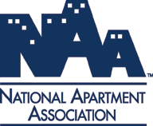
Does your Property have the fastest technicians around?

Here’s your chance to prove it!
Invite your pros to come and compete in Maintenance Mania® where they could earn the title of National Champion*.

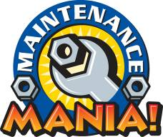
What is Maintenance Mania®?
A competition in which apartment maintenance technicians from around the country face challenges that test their skills and knowledge.

Check out the video on www.aptassociation.org

Eight Challenges to Prove Their Skill:
Presenting Sponsor:
- Bradford White Water Heater Installation
- CFG Faucet Installation
- Fluidmaster Duo Flush Toilet Conversion
- Frigidaire Icemaker Installation
National Sponsors:
- Kidde Fire & Carbon Monoxide Safety Installation
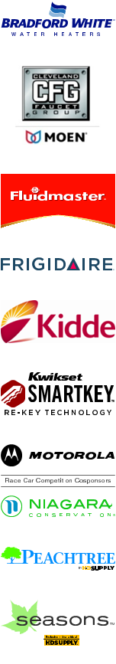
- Kwikset Key Control Deadbolt Test
- Seasons Ceiling Fan Installation
- Motorola & Niagara Conservation Race Car Competition

All they need to do to compete is build a race car from maintenance products ahead of the event.

They can compete in one or all games, with your cheers and support everyone is sure to have a good time.

When?
- Thursday, March 24, 2014
- 11:00 a.m. to 4:00 p.m.

Event Schedule

Car check-in opens: 11:00

Practice time: 11:00 – 12:00. Competitors check out all the games

Competition begins: 12:00

Where?

City Convention Center

101 Main Street
Springfield, XZ 19000

Contact: John Doe at (555) 555-5555

*Participants must compete in all seven challenges plus enter a car in the race car competition to be able to qualify for a spot in the National Championship.

