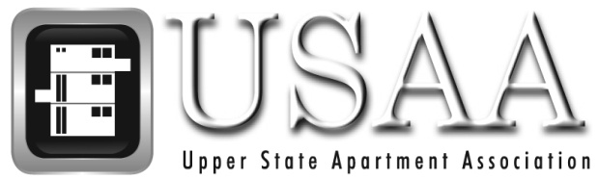

Thank you for requesting information about the Upper State Apartment Association. Our goal is to strengthen the multi-family housing industry through education, legislation, and participation. Membership is open to apartment communities, management companies, owners and product & service providers.

Monthly meetings are an excellent way to meet other USAA members and connect with key industry leaders. USAA keeps you updated on membership news via the Membership Directory and a quarterly E- Newsletter outlining upcoming events and classes, as well as our online calendar of events.

When you join USAA your membership automatically includes membership in the South Carolina Apartment Association as well as the National Apartment Association. You will receive NAA's industry publication, "UNITS”, which keeps our members updated on issues regarding the multi-family housing industry.

USAA also offers educational designations through the National Apartment Association including NALP, CAPS, CAS and CAM designations. We also offer the required Property Management course and several other pertinent classes to earn CEC’s such as fair housing, customer service, leasing and marketing and much more!

Through active participation, you can gain a valuable network of professional contacts to aid you in marketing and economic transactions. Board representation, sponsorship opportunities and committee involvement can also deeply enrich your membership experience.

Attached you will find our membership application. If I can be of further assistance regarding joining the USAA, please feel free to contact myself or our Education Director, Rose Stolarski.

Sincerely,

Laura Little
Executive Director

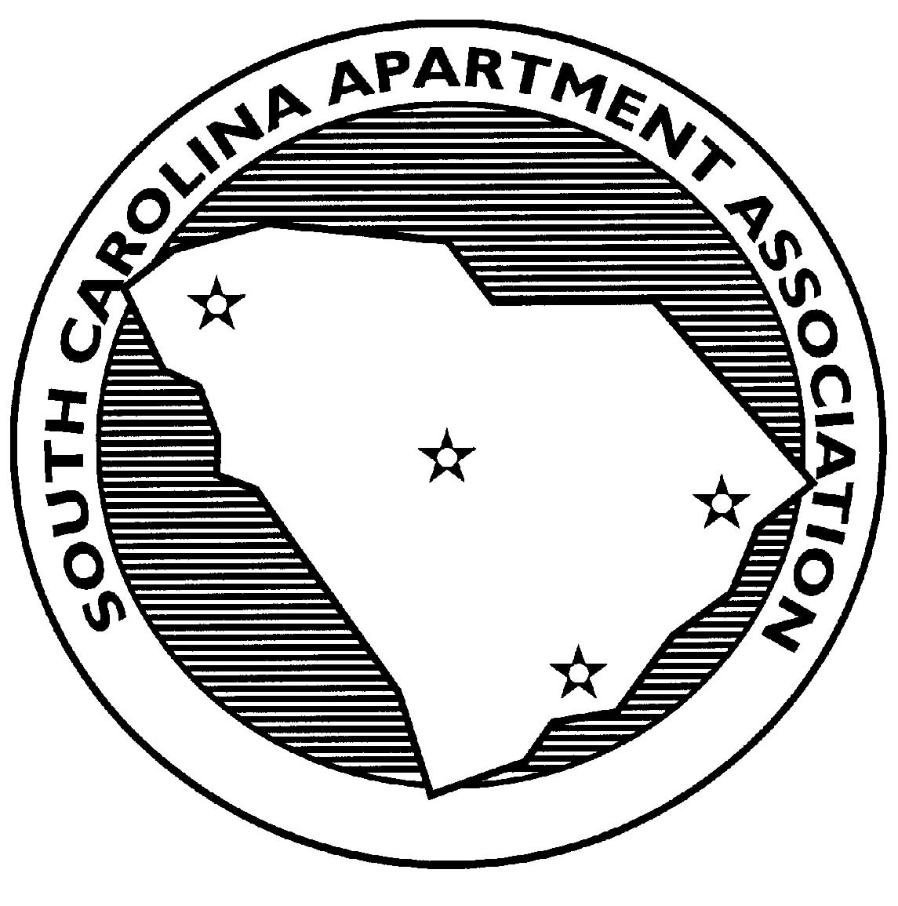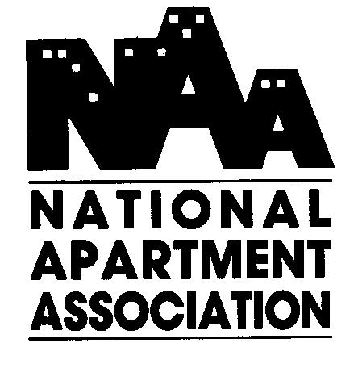
Upper State Apartment Association
211 Century Drive Suite 104 - D Greenville, SC 29607
Phone: (864) 242-0200 Fax: (864) 242-2807
www.upperstate.org

