Guest Article September 2015
Bob Harris bob@rchcae.com
Is the President Ready?
Purpose, Plan, Performance

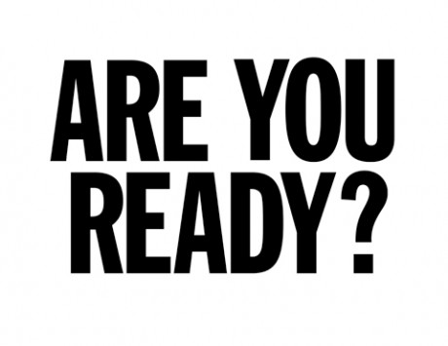
Is the incoming chief elected officer, AKA president or chairman of the board, ready for the job?

Transitioning from VP or president-elect to the office of the president requires preparation. He or she assumes responsibility for advancing the mission, serving the members, protecting the assets, solving the problems, addressing the media and inspiring the leadership, among other duties. The more one prepares --- the better the results.

Use the self-paced diagnostic tool built upon three governance foundations: Purpose, Plan and Performance. Finish the assessment then schedule a meeting between the incoming president and executive director to discuss each person’s image of success for the term ahead.

Purpose – The reason for existence.

- Duties - Do I understand the responsibilities of the chief elected officer? Is there anything I don’t feel comfortable with for which I should find help, for example rules of order or finances? Am I able to inspire others to fulfill out their volunteer roles?

- Organizational Purpose – Is the mission statement understood by everyone, including myself, my leadership team and stakeholders? Am I ready to ensure that all efforts and resources are directed to advancing the mission? Can I recite the mission, realizing that it should frame nearly every action and discussion?
- Governance – Have the governing documents been provided to the leadership team, including bylaws, budget and strategic plan? Is the distinction clear between the principles of board governance and staff management?

Plan – The intent or roadmap to achieve results.

- Intent – Am I able to communicate a clear vision of a successful year? Have I communicated my vision to the leadership team and staff? Am I confident that everything I suggest, say and do will advance the organization, leaving it in better form than when I started my term?
- Strategic Plan – Am I conversant about the strategic plan? Is the leadership fully versed about the plan? Will it need to be updated or drafted during by term?
- Business Plan – Are assignments tracked with a program of work or business plan? Will progress on the strategic plan and program of work be reported at board meetings?
- Agenda – Do I understand a well designed board agenda is a collaborative effort between the president and executive director? Will the format lend itself to efficient, effective meetings? Will re-crafting the agenda improve results?
- Committees – Committees supplement the work of the board. Have I inventoried them, aligned them with the strategic plan, appointed chairs and assigned current-year assignments? Do committees have board and staff liaisons to champion their efforts?
Performance – The process and behavior for carrying out the plan.
- Personal Performance – Am I prepared for my role, able to inspire and readily share the credit with others? Is my leadership style authentic? Do I have the support of my company and family for the time and resources required personally?
- Organizational Performance – Am I focused on outcomes and members’ needs? While many ideas will arise, do they lend themselves to the broader good of the organization? How should we assess our performance?

- Results – Will results be achieved throughout and by the end of my term? Are there sufficient resources to support the work at hand? Am I able to think beyond my term of office to lay a solid foundation for future leaders?
- Succession – Though I am just beginning my term, am I able to identify future leaders? Can I maximize the role of the incoming president to help him or her prepare?

Preparation pays off. The three Ps – Purpose, Plan and Performance, keep the chief elected officer focused.

# # #

