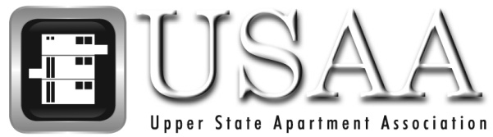

Thank you for renewing your membership with the Upper State Apartment Association. You are valuable to the continued success and growth of USAA.

Your members-only benefits include:

- Ten dinner meetings per year included in Dues (excluding trade show and crisis fundraiser)
- Membership in SCAA and the National Apartment Association
- State customized lease/addendums
- Networking with industry peers
- Nationally recognized designation educational opportunities
- Education Center rental opportunities
- Membership Directory/Buyer’s Guide
- Legislative updates
- E-news updates
- Required Property Management Pre-Licensing course with SC LLR-approved school and instructors.
- Access to additional features via the USAA website www.upperstate.org:

  - Member listings by name and category, job bank and calendar of events
  - Your personal log in ID: ______________ Password: ______________

We look forward to another exciting and successful year with you! If you have any questions about your membership, please feel free to contact us at (864) 242-0200.

Sincerely,

