&
2016 Winter Board of Directors Meeting
January 13 - 14

One Ocean Resort & Spa
1 Ocean Boulevard
Atlantic Beach, FL 32233
(904)249-7402 / 800-874-6000
https://www.oneoceanresort.com/

Wednesday, January 13
NAA Executive Committee Meeting (Invite Only) | 1 p.m. – 2:30 p.m. | Conference Room
NAA Board Orientation | 2:45 p.m. – 4:45 p.m. | Atlantica Ballroom
NAA Board Meeting | 4:45 p.m. – 6:30 p.m. | Atlantica Ballroom
NAA Board Reception | 6:30 p.m. – 7:30 p.m. | Verandina
Thursday, January 14
NAA Board Breakfast | 8:30 a.m. – 9:45 a.m. | Pristina
NAA Board Meeting | 9:45 a.m. – 6 p.m. | Atlantica Ballroom
NAA Board Lunch | 12:30 p.m. – 1:30 p.m. | Pristina
Group Event (1 block from Hotel) | 6:30 p.m. – 9:00 p.m. | 60 Ocean
*Please note meeting rooms are subject to change.
*All meeting rooms are at the Marriott Marquis unless otherwise noted.

*
HOTEL RESERVATIONS & CUT-OFF DATE
Hotel rooms are available at One Ocean Resort & Spa for $199 per night plus tax. Resort fee has been included in the room rate and includes such services as: WiFi Access, Coffee & Tea Services, Docent Services, Garment Steaming, Personalized Refreshment Center, Shoe Polish, Exercise Facilities and Nightly Turn Down Service.

All rooming reservations for the NAA Executive Committee and Board will be made by NAA on their behalf. Individuals will not be reserving hotel rooms on their own. Please make sure to submit your arrival and departure dates for the meeting, via email to Diane Bombard by Monday, December 14. After December 14, we will be releasing any extra rooms back to the hotel and cannot guarantee availability. If you are planning to extend your stay at One Ocean Resort, please indicate those dates in your arrival/departure. NAA will cover the cost of room and tax for a maximum of 3 nights.

REGISTRATION
Registration for the Winter Board Meeting must be done online. All registrations must be received no later than Monday, December 14, 2015. If you will be bringing a guest, please make sure to mark the Guest Registration.

CANCELLATION
Reservations must be canceled 72 hours prior to arrival to avoid forfeiting one (1) nights’ deposit of room and taxes. Please email any room cancellations to Diane Bombard. Any cancellations not received 72 hours before arrival will be charged back to the individual.
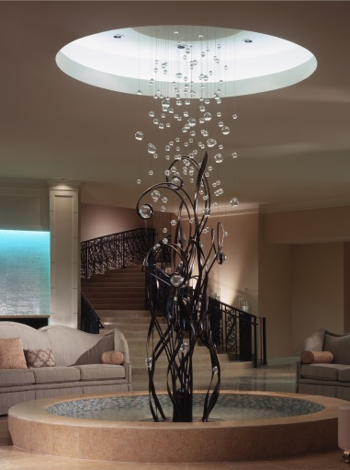
TRAVEL INFORMATION
- Airport: Jacksonville (JAX) – 24 Miles (30 minutes)
- Ground Transportation: Cab from JAX to One Ocean Resort is approximately $65
- Driving: Driving directions can be found at: One Ocean Resort, Location

TEMPERATURE
- Highs in the 60s
- Lows in the 40s

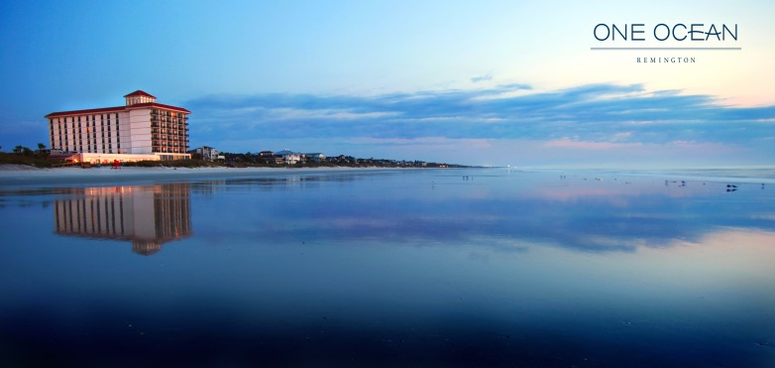
DRESS
Dress for the meeting is business casual.

See what Coastal Living had to say about One Ocean (http://dailycatch.coastalliving.com/2015/10/06/jacksonville-florida/)

